Once you are able to have installed python and setup you IDE. We need to test if the things are working properly fine:

For that you need to run the following code below:

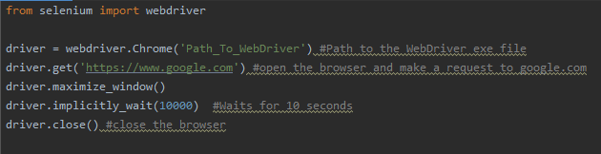

Let’s do a google search using selenium

Make a new file called GoogleSearch.py and type the code:

